Fiona Soe Paing and Open Road present

Sand, Silt, Flint
immersive music performance with film and live vocals

“Startling Scottish balladry with a global scope.”
The Guardian * * * *

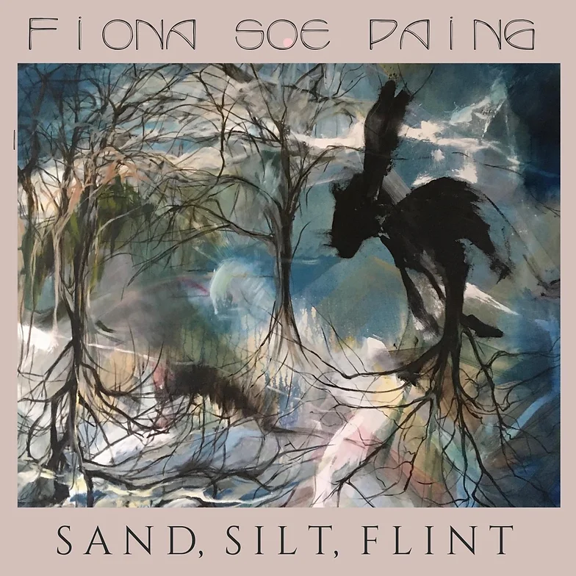

Promotional Pack

Contacts:

Lesley Anne Rose | UK Producer | Open Road Ltd
info@openroadltd.co.uk | +44 (0) 771 934 3805

Tour Producer
Martin Aitken | producer@openroadltd.co.uk| +44 (0) 7952 808 772

Fiona Soe Paing and Open Road present
Sand, Silt, Flint

“Startling Scottish balladry with a global scope.”
The Guardian* * * *

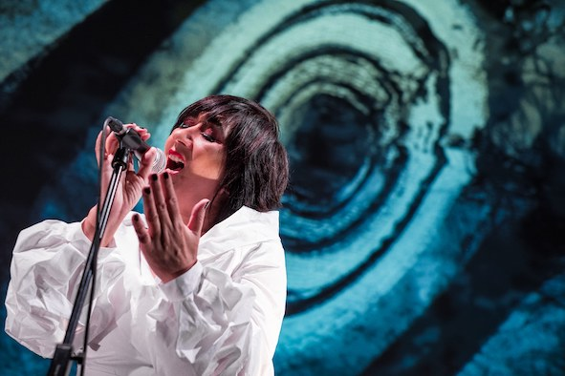
Sand, Silt, Flint is the new album and immersive performance by Scottish avant folk composer and vocalist Fiona Soe Paing. Fiona’s re-imagined traditional ballads draw on the folklore, landscape, language and rich balladry tradition of North East Scotland. Her performance interweaves Fiona's mesmerising live vocals with archive sound, field recordings, traditional instrumentation, film and animation. Sand, Silt, Flint is an uncanny re-telling of ancient tales for new times and is also available to experience as a series of sound walks at locations around North East Scotland.

Reviews

“Soe Paing delivers that rarest of treats, a sublimely powerful and lingering experience…”
SONGLINES MAGAZINE * * * *

“…dark and extraordinary versions of traditional songs… I am already a big fan.”
ELIZABETH ALKER, BBC RADIO 3 UNCLASSIFIED

‘…next generation folk music. A masterful collection, rooted in place but otherworldly in spirit”
FINDING LAND FOLK SHOW

“…Avant-garde folk doesn’t get much better than this.”
SONGLINES MAGAZINE

“Massive Attack meets bothy ballads in north-east musician’s cutting-edge album.”
THE PRESS AND JOURNAL

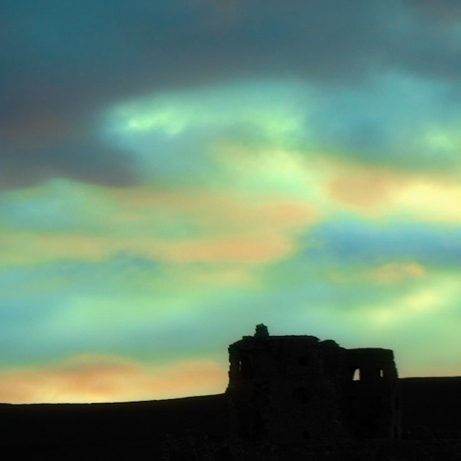

Production Notes

Running Time
One hour

Technical Information
Cast and company: 1 performer and 1 stage manager/technician
Space requirements: 4m wide x 3m deep minimum
Black out: Partial blackout is necessary
Set up time: 3 hours
Strike: 1 hour
Light and sound: We can travel with our own sound system, projector and screen.
However, if this equipment is available in house, we may request use of it instead. We would like to utilise in-house lighting.
Electricity/power: 2x 13a sockets

There are no loud bangs or strobe lighting effects in the show.

Creative Team

Composer & Vocalist Fiona Soe Paing

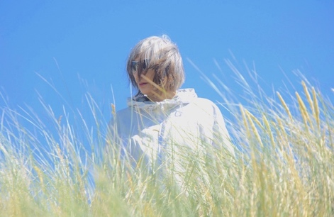
Fiona uses experimental electronica production combined with her own vocals and found sounds to explore identity, heritage and belonging. Her debut release in 2007 was included on the Warner Music compilation “Sound of The World” by the BBC world music DJ Charlie Gillett. The solo album Alien Lullabies was released in 2016, alongside a run of her show in the Edinburgh Festival Fringe, as part of Creative Scotland’s Made In Scotland showcase programme. Fiona has also collaborated with theatre and filmmakers on installations and site-specific audio-visual work.
www.fionasoepaing.co.uk

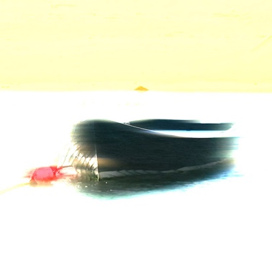
Animation & Visuals: Isla Goldie/Dudendance

Isla Goldie is a photography and visual artist with a specific interest in the human condition, in particular the fleeting moments of fragility, preciousness and unpredictability that it can create.
Islagoldie.myportfolio.com

Dudendance Theatre have pioneered an original voice by layering film, sound, narrative and movement. The company works with international collaborators as well as non-professionals, establishing an international reputation for performance through its work in Germany, Belgium, Canada, Brazil and Argentina and Scotland.
https://dudendance.wordpress.com

Sand, Silt, Flint includes contributions from traditional Scottish, classical and experimental musicians, including renowned fiddle player Paul Anderson MBE and cellist Alice Allen.
Background

“I already knew a few folk songs from the North East, but never realised the tradition was so immense… when I discovered that one of my relatives was one of the original ballad singers, that was a lightbulb moment for me, when everything clicked into place.”

Fiona developed the idea for Sand, Silt, Flint while she was researching her family history. On returning to Aberdeenshire after many years living outside Scotland, Fiona felt disconnected from her roots and heritage. A desire to re-connect with her Scottish roots led her to revisit some of the landscapes and stories she knew as a child. Fiona was excited to discover that she is related to one of the original North East ballad singers, John Strachan, who was recorded by the folk historian Alan Lomax. Fiona was inspired to carry this link with the past, into the future, by recording her own electronica version of one of John Strachan’s songs. This gradually developed into the idea for Sand, Silt, Flint and to re-imagine and re-interpret some of North East Scotland’s traditional ballads and folk tales for new audiences, presenting the work in a novel and engaging way, keeping the stories alive and bringing the tradition forward in a new direction. Using the Doric dialect of the North East, Fiona re-imagines traditional ballads from the area, creating new songs inspired by landscape and folklore.

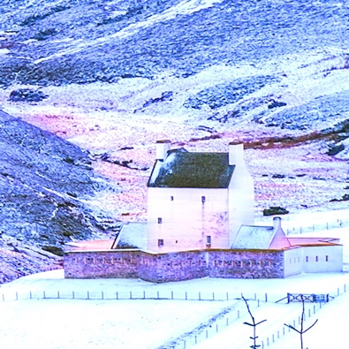
Sound Walks
Each Sand, Silt, Flint song is linked to a specific North East location which reach from the bleak expanses of The Lecht in the Cairngorms, to the dramatic Banffshire coast. We are delighted to also present the album as a series of outdoor geo-located sound walks in the Echoes mobile app; using smart-phones and headphones, the audio is triggered by GPS, enabling audiences to experience the music in the environments which provided its inspiration.
The walks have been researched and written by travel writer and producer Lesley Anne Rose.

About Open Road
We believe that culture and creativity inspired by people and place transforms lives.
Our mission is to be a creative, entrepreneurial organisation rooted in North East Scotland (‘the North’), but with a global vision: using arts, culture, heritage and the natural landscape to contribute towards health and wellbeing, tourism and environmental sustainability.
www.openroadltd.co.uk

More Information

https://www.openroadltd.com/projects/sand-silt-flint/

www.fionasoepaing.co.uk

